**Report for first assignment in deep learning**

Yuxi Mao

**I.Introduction**

In this assignment, I Implement the Logistic regression. The data set is the MNISET,which is simple computer vision data set. Then I just training the model.

**II.Objectives**

In this project I want to create a model that use the Logistic regression. After the practice I will get a height efficiency model and also know how to use the softmax the MNIST and use the tf.argmax to evaluation it.

**III.Approaches/Method**

I use the Softmax regression as the methods. softmax regression is a simple model that can assign probabilities to object being several different things. The 2 step of softmax are firstly add up the evidence a the begin of the input, then convert the evidence to probabilities.

The softmax regression can looking as following:

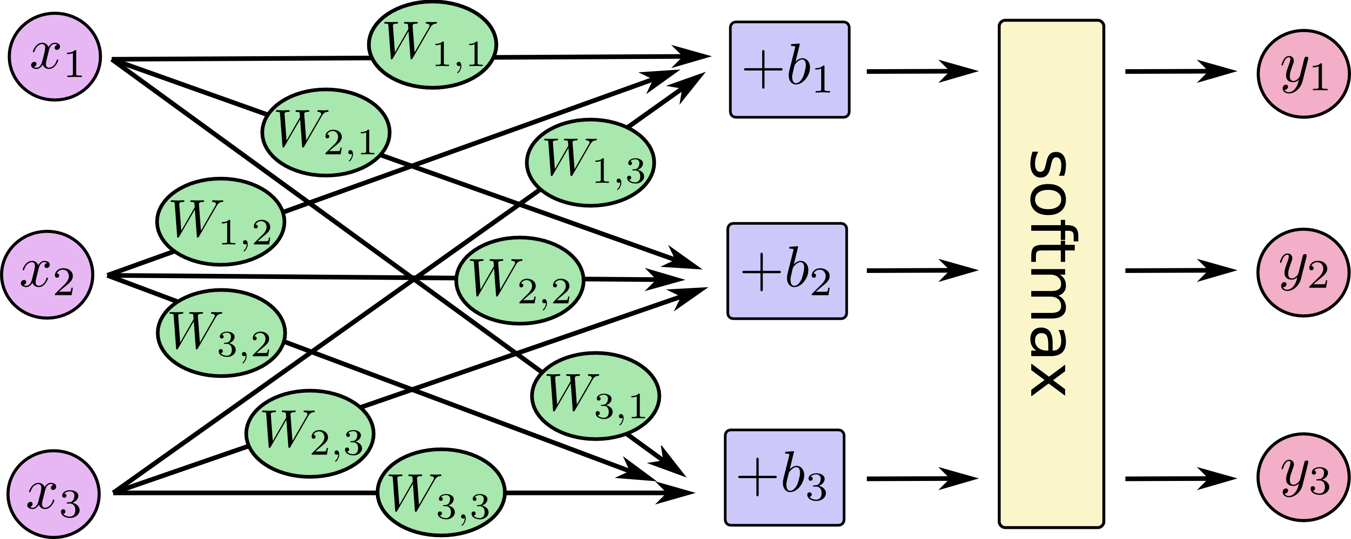

If write as equations then:

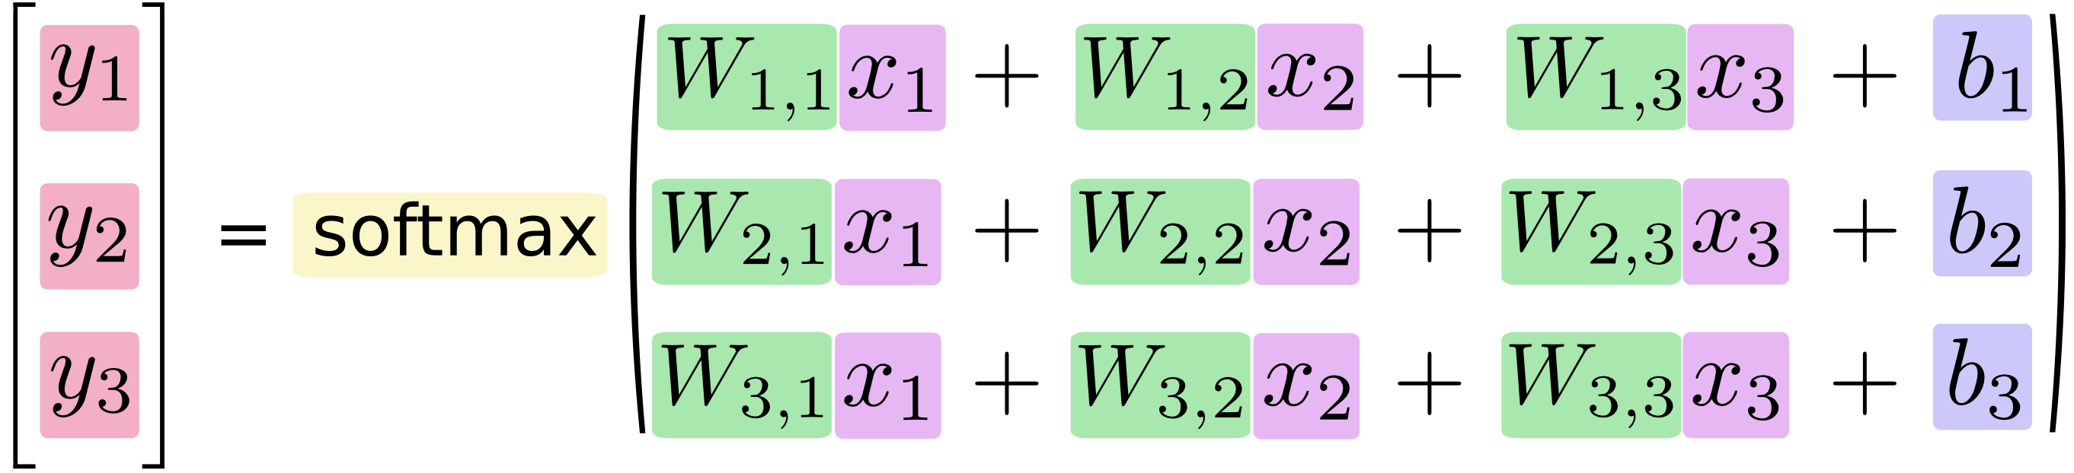

And we can just write:

x

**IV.Workflow**

Now I will show the workflow of my project.

Firstly, I just import the tensorflow: **360截图17650107121118116**

Then, I need to input the MNIST data set:

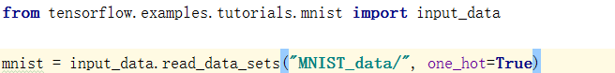

Then create the variable

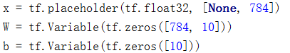

Then, we need a line to define the model:

3

So now we have our model here. Then we need to training it.

The cross-entropy will help a lot. To implement it, we need to create a new placeholder:

4

Then implement the cross-entropy function:

5

Take TensorFlow to train it, launch the model in InteractiveSession, Then create an operation to initialize the variables:

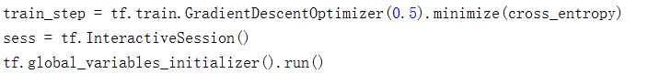

Then we can training it. Lets try 500 times:

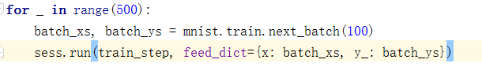

To know if our model is good efficiency, we just evaluating it.

We use tf.argmax here. It will return the booleans value and we let true=1, false=0, find the mean value. So taht we can know the efficiency:

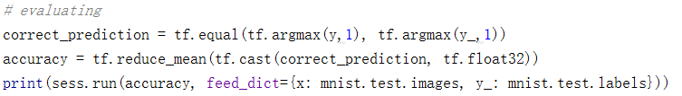

Then, we get the result:

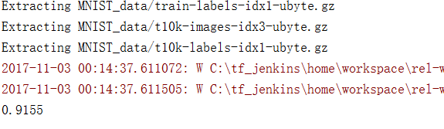

**V.Datasets**

I use the MNIST data set. MNIST data set is hosted on Yann LeCun`s website, here is the like of the data set:[http://yann.lecun.com/exdb/mnist/]. And it has the three part: 55000 points of the training data, 5000 of the validation and 10000 points of test data. Every data point has two parts: the image of handwritten digit and corresponding label. The MNIST are bunch of points in a 784-dimensional vector space.

**VI.Parameters**

X: Its a symbolic variable.Its not a specific value, when we ask TensorFlow we will input the value for it.

W,b: They are as tensors full of zeros.W was [784,10] because we need to multiply 784 dimensional vectors image by 10 dimensional vectors, b was [10] so that it be add to the output.



Y: It is a line to define the model.

3

**VII.Evaluation & Discussion**

We use tf.argmax here to evaluation the model. It can show the index of the highest entry in a tensor along some axis. I will use the tf.equal to check if the prediction matches is true or false. It will return the booleans value so that we just let true=1, false=0, then put them in a list like [T,F,T,T]=[1,0,1,1], then we can find the mean value of the list. Then the output value will show the efficiency of the model.

I let the model try 500 times and the result are: 0.9155, and then I just keep running it, the result are 0.912, 0.9152, 0.9124. So the result are around 0.912-0.916, the efficiency is very height, but it can still be more valid.

**VIII.Conclusion**

In this project I use the softmax as the method, use the MNIST as the data set to create a Logistic regression model. Then I just training it then tf.argmax to evaluation its efficiency. After the the result the efficiency is not bad, but still have more space to improve.